Step 1) For Jenkins Pipeline we need to install the Ansible plugin.
Go to Manage Jenkins > Manage Plugins >Available > search Ansible.

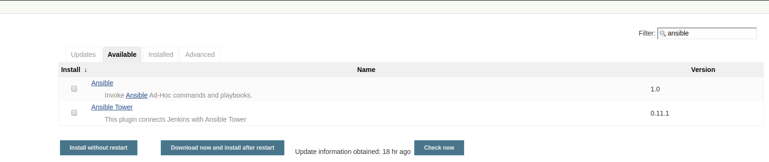

If you are already installed Ansible Plugin on your Jenkins It will display in the Installed section.
Now we can see the Invoke Ansible Playbook option in the Build Environment section but we need to configure Ansible path for Jenkins.
Now let’s configure Ansible on our Jenkins.
Go to Manage Jenkins > Global Tool Configuration > It will display Ansible on the list.

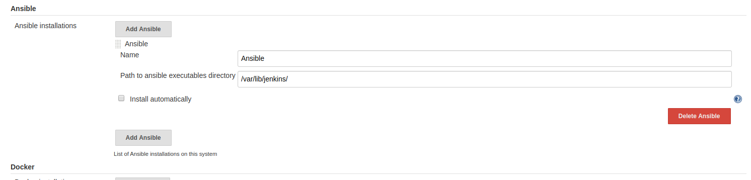

Now let’s Create New project to execute Ansible playbook.
Step 2) Goto Jenkins Home > New Item > Create New Freestyle Project.

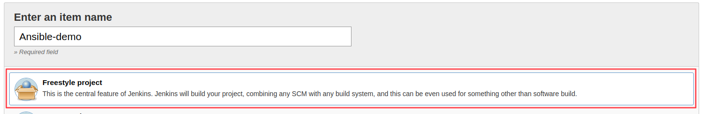

We create a new freestyle project now lest configure our project.
Goto source code management section and add your code repository here you are free to use any of the source code management platforms like Github, Gitlab and also Bit bucket.

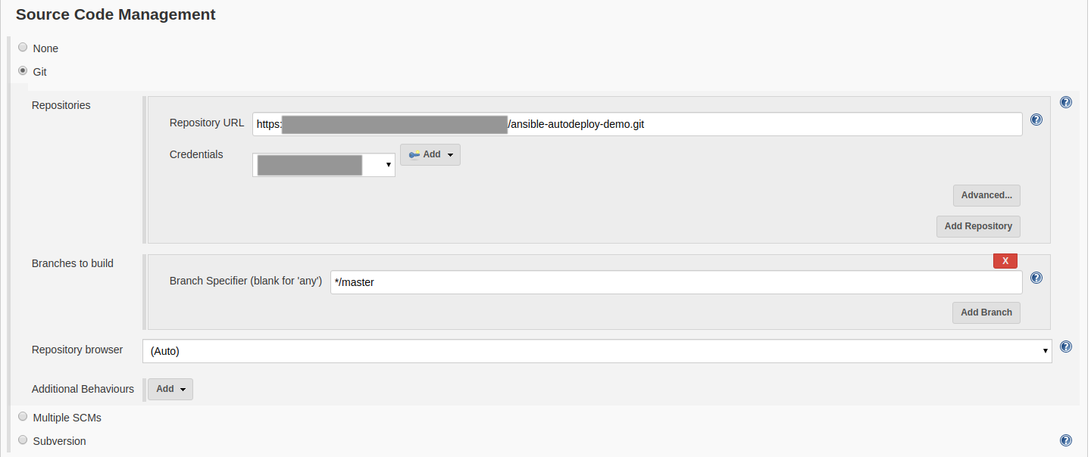

Now let’s configure ansible plugin.
Goto Build section and select Invoke Ansible Playbook. Once you select that option it will display ansible-playbook configuration option like below.

